New York Times
Frequent Flier

Finding Adventure and Trying to Save It
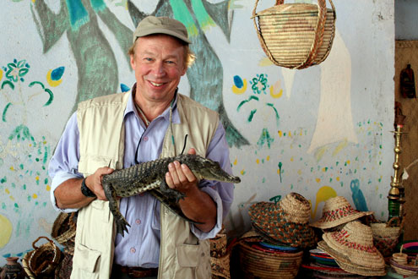

Photo by
Laura Hubber
Richard Bangs is co-founder of Mountain Travel Sobek, an adventure travel company in Emeryville, Calif.

By RICHARD BANGS
Published: June 26, 2007
I have been lucky enough to convert my passion for travel into a successful travel business. For me, business travel is not misery — it is pleasure. And in the 30 years that I’ve been doing my work, I hope that I have made a difference in the way that travelers view the world.
Yet in my sleep I often wonder if I could have done more. In the ’80s, I made the first raft descent of the Alas River in Sumatra, running through the largest orangutan reserve in the world. Timber poaching has reduced the once-luxurious habitat to a scrawny shadow. The “men of the forest” are on the brink of extinction, and the wondrous river run is gone.
I have witnessed many special places preserved and lost, and the critical vector was more often than not the number of adventurers or outdoor sports enthusiasts who trekked the landscape, floated the river or climbed the peak and were touched by the unique qualities of beauty, spirit and challenge. When such a space became threatened, there was a constituency for whom the place was personal, a collective force ready to lend energy, money and time to preservation.
The Colorado still dances through the Grand Canyon largely because those who rafted this cathedral rallied against a proposed dam. The Tatshenshini in British Columbia, a river I pioneered in the mid-70s, with the highest concentration of glaciers, grizzlies and bald eagles in North America, was almost victim to an open-pit copper mine. But those adventurers who had made its passage fought fiercely and won protection.
  Adventures with Purpose | Small World Productions  140 Lakeside, Suite 200, Seattle 98122  206.329.7167  info@travelsmallworld.com  www.AdventuresWithPurpose.TV
(more)
New York Times
Frequent Flier
Finding Adventure and Trying to Save It
Page 2
In the late ’70s, I led the first descent of Chile’s Río Bio-Bio, a tumbling gem that offered up some of the finest white water in the world. I tried to persuade as many folks as possible to come carom this course, but not enough. A local power company rolled over resistance and broke the wild water with a series of dams.
This has been a cheerless theme to my adventure travel over the past three decades. So often I would stumble on a spectacle so bravura it would speed the blood, or run a river gantlet so challenging it would validate existence. But then upon return, I would discover it was less so, or gone.
It is a paradoxical notion that the places we wish to remain protected and wild cannot become so unless boated, hiked, biked, sailed, hunted or in some way actively engaged. And I’m part of that because of my business.
In 1981, I joined Zambia’s president, Kenneth Kaunda, at a function in Lusaka to help save the last of the black rhinos of Zambia by promoting photo safaris. I pledged to motivate more to come and participate, but I never really made good on the promise. When I returned last year, all the rhinos were gone.
As the founder of Sobek, I’ve spent a career designing and conducting extreme adventures to the far corners. But the graveyard of my own sacred places gone speaks to regrets, and quests not fulfilled.
This summer, I am devising a raft trip in Fiji for my 12-year-old son and his friends. I hope they are swept away by the glorious displays of tropical birds and flowers, and baptized into the marvels of the Fijian adventure. And I hope when the time comes for volunteers to save what they have seen, their hands and voices will be raised high.
By Richard Bangs, as told to Joan Raymond. E-mail: joan.raymond@nytimes.com.

Adventures with Purpose | Small World Productions  140 Lakeside, Suite 200, Seattle 98122  206.329.7167  info@travelsmallworld.com  www.AdventuresWithPurpose.TV

